**ASSIGNMENT 32.3**

Write a Java client API to perform following operations:

● Use HBaseAdmin class and create the table named company with one column family name details.

● Create the method name insert and use put class to insert records to company table.

STEP 1: WRITE A JAVA CODE TO CREATE A TABLE IN HBASE

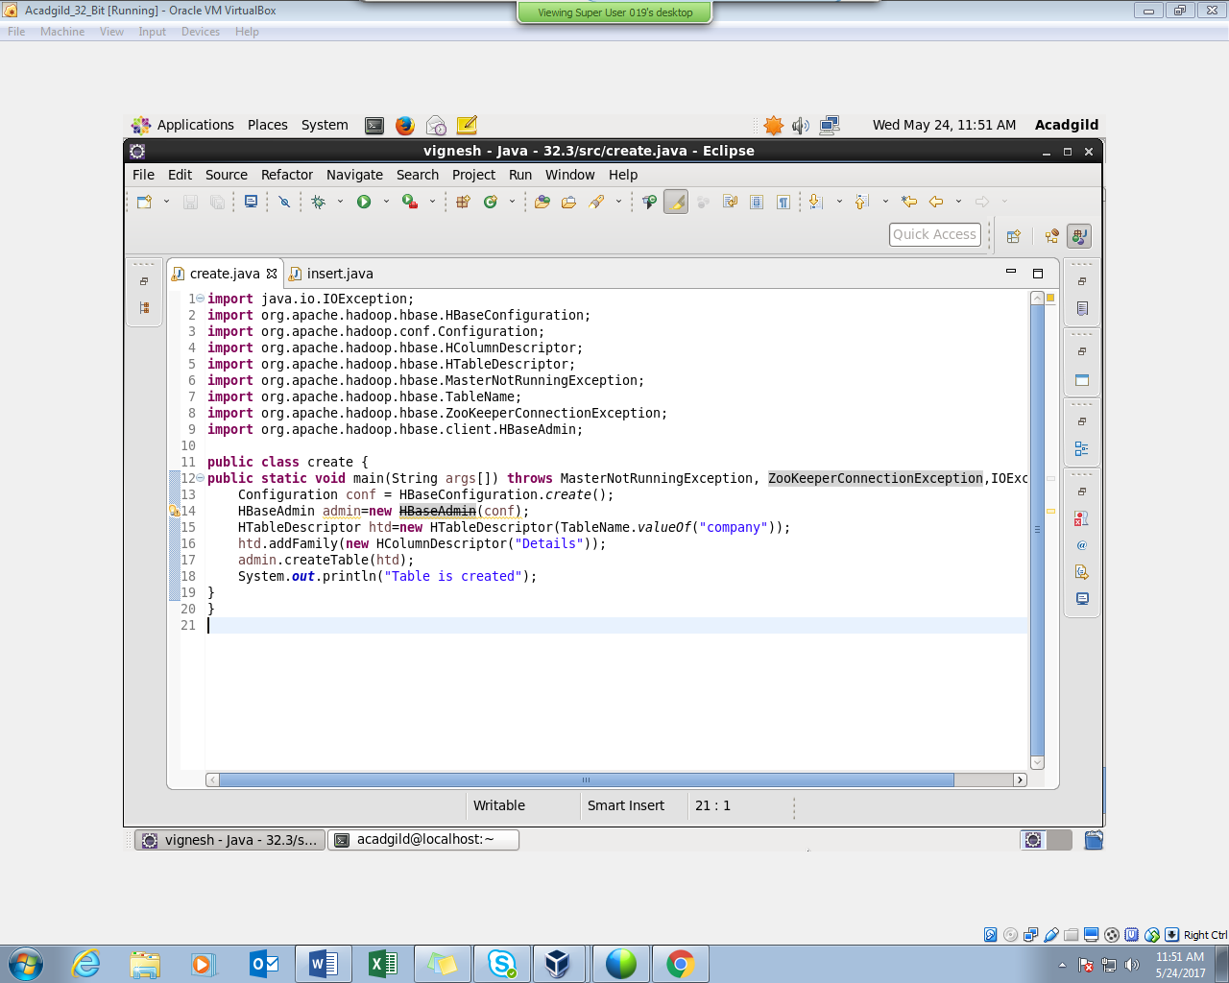

STEP 2: TABLE IS CREATED IN HBASE BY RUNNING THE JAVA CODE (RUN AS APPLICATION) IN ECLIPSE

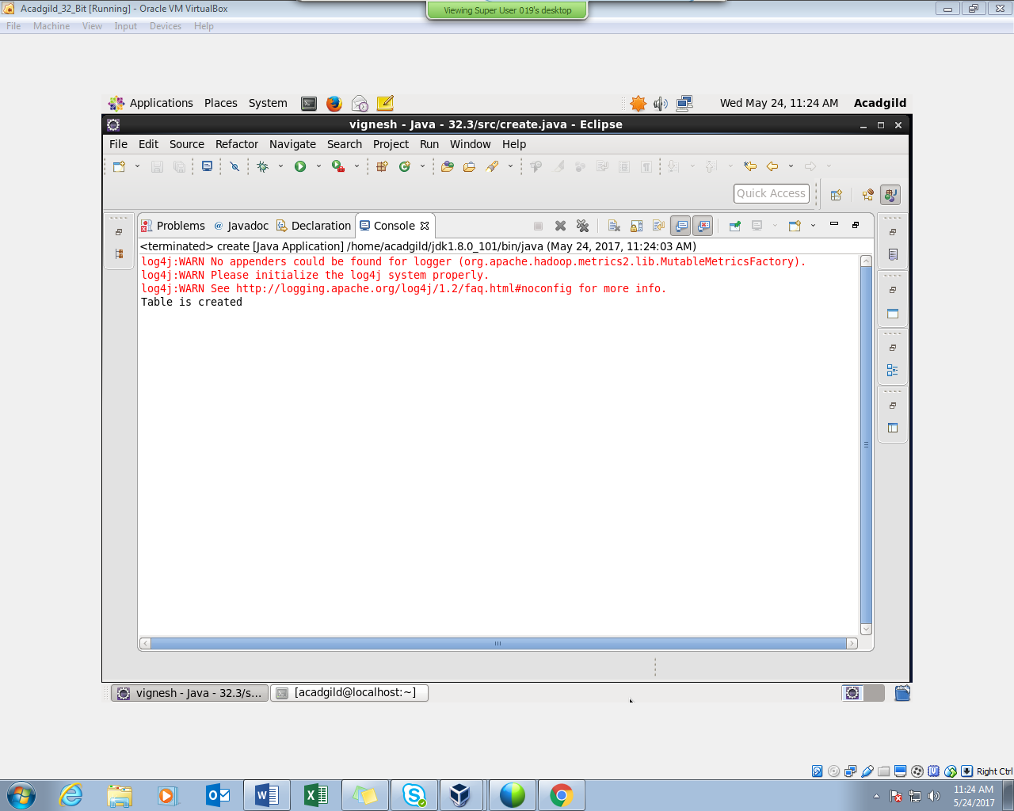

STEP 3: USING ‘LIST’ COMMAND , SHOWING THE TABLES IN HBASE

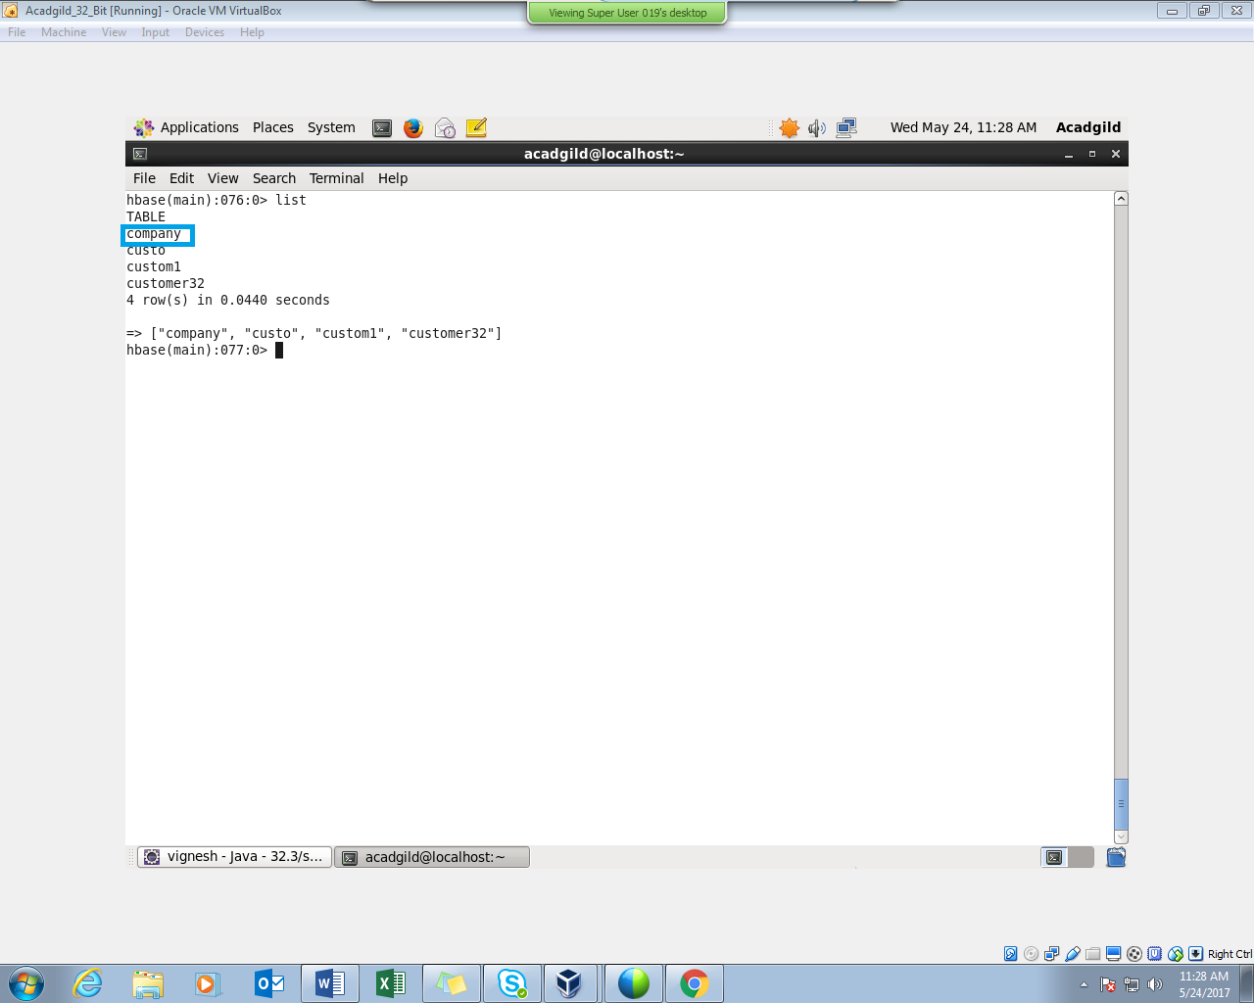

STEP 4: WRITE A JAVA CODE TO INSERT DATA INTO THE TABLE “COMPANY”

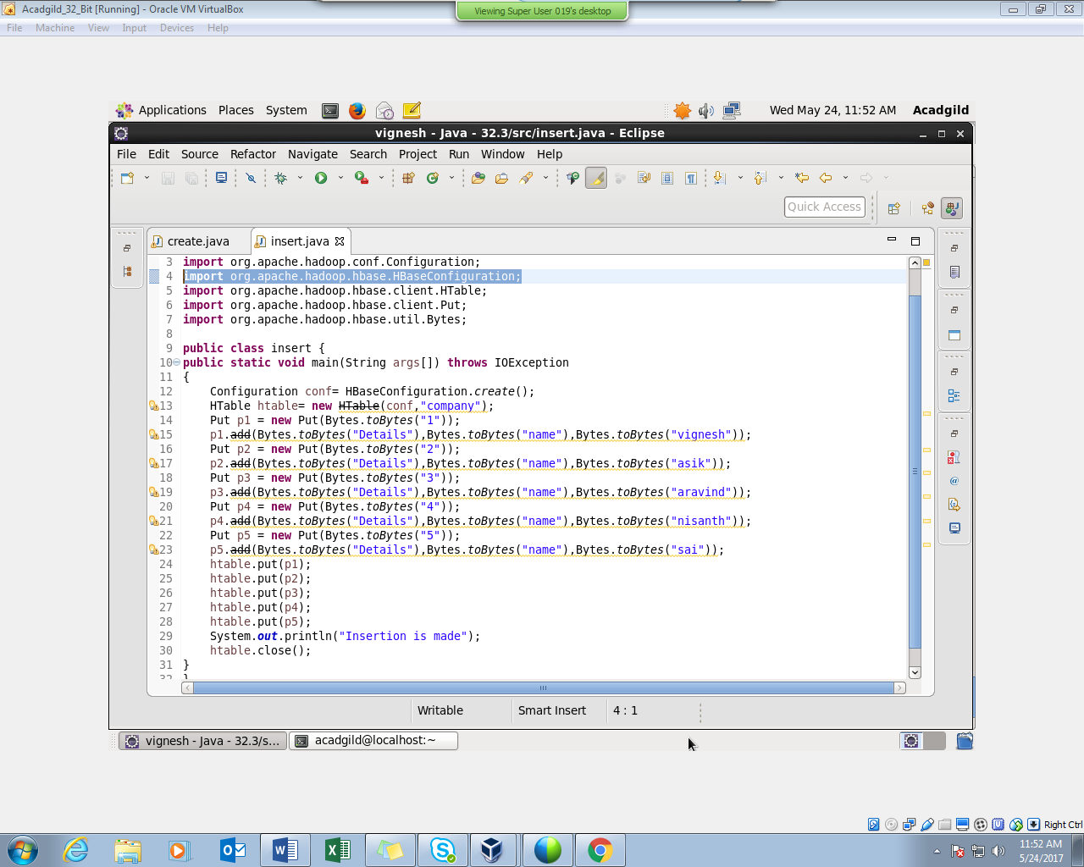

STEP 5: INSERTION IS MADE BY RUNNING THE JAVA CODE IN ECLIPSE (RUN AS APPLICATION)

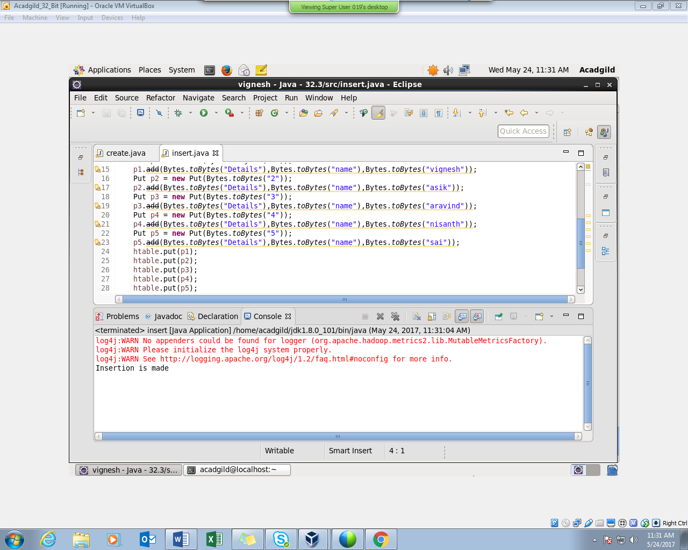

STEP 6: INSERTION WAS SUCCESSFUL AND SCAN COMMAND IS USED TO CHECK IT.

